Armidale Junior Rugby Club

AGM Report 2025

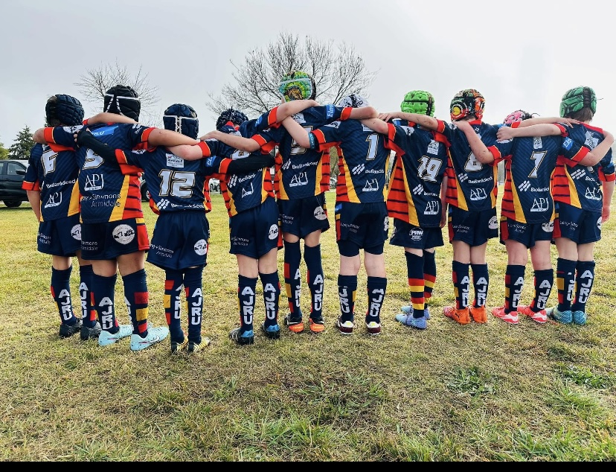

Contents
- Presidents Report
- Secretary Report
- Financial Report
- Registrations for 2025
- List of ARJU awards 2025
- List of representatives for both 15 a side and 7’s state Championships

Executive and Committee Members
Executive
1. President | Sarah Grace-Booth
2. Vice President (U6s - U12s) | Tim Bartlett-Taylor
3. Vice President (U14s - U18s) | Ben Lawry
4. Secretary | Clair Percival
5. Treasurer | Jen Brown
6. Registrar/Compliance Manager | Steph Belson
General Committee
1. Merchandise Manager & Training/Game Gear Manager | Jess Sisson
 | Jen Brown
 | Naomi Wright
2. Social Media Manager | Ruth Bartlett-Taylor
3. Under 6 - Under 12 Coordinator | Dave Percival
4. Under 14s - Under 18s Coordinator | Claire Percival
5. BBQ Manager (Friday Nights) | Craig Wright
6. Sponsorship Coordinator | Ben Ryland
7. Events Coordinator | Kirrily Ritchie
8. Player publications compliance manager | Steph Belson
9. Gala Day Organiser | Mel Dennison
 | Naomi Wright

Armidale Junior Rugby Club

2025 President’s Report

Annual General Meeting

It is my pleasure to present the President’s Report for the Armidale Junior Rugby Club for the 2025 season. This year has truly highlighted the strength of our community and the generosity of our sponsors. The ongoing support from local families, businesses, and community partners continues to make a meaningful difference to our club. Whether through financial contributions, services, or simply turning up each weekend to cheer on our young players, your involvement ensures that our club remains strong, welcoming, and well-resourced.
I would like to express my sincere gratitude to all our sponsors. Your continued investment enables us to provide quality equipment and create opportunities that enrich the sporting experience for every child who pulls on an Armidale Junior Rugby jersey. We value your partnership and the vital role you play in supporting rugby development in our region.
A special thank you must go to our dedicated committee, whose hard work is the backbone of this club. Their commitment to organising registrations, coordinating events, managing finances, supporting teams, and handling the many behind-the-scenes responsibilities ensures our season runs smoothly. Their professionalism and passion are evident in everything they do, and I am deeply appreciative of the countless hours they devote to the club.
One of the most significant developments this year has been the introduction of the senior women’s teams. This has been a major milestone for our club and a proud step forward in strengthening pathways for girls and women in rugby. The enthusiasm, skill, and spirit shown by our senior women have set an inspiring example for our younger players and have helped further cement our club as a place where rugby is truly for everyone.
The 2025 season has also been a strong one for our junior players. Our players have shown outstanding sportsmanship, resilience, and enthusiasm, representing the club with pride both at home and away. Several players achieved representative honours this year, reflecting their dedication and the quality of coaching and development provided within the club. While competitive success is always exciting, the true achievement lies in seeing our players grow in confidence, develop new skills, and enjoy being part of a team.
None of this would be possible without the tireless efforts of our coaches, managers, and volunteers. Your willingness to give your time whether at training, on game days, or in support roles creates a safe, supportive, and enjoyable environment for our young athletes. Your patience, encouragement, and leadership are essential to the success of our club and the development of our players.
Throughout the season, we continued to prioritise player development with a focus on safety, fundamental skills, and teamwork. Our inclusive approach ensures every player, regardless of experience or ability, has the opportunity to learn and grow at their own pace. This commitment to positive sporting experiences remains central to who we are as a club.
Looking ahead to the 2026 season, we remain focused on strengthening player pathways, supporting our expanding women’s program, enhancing volunteer resources, and continuing to provide an environment that reflects the values of rugby respect, integrity, passion, discipline, and teamwork. With the continued support of our community, sponsors, and families, the future of the Armidale Junior Rugby Club is bright.
Thank you once again to everyone who contributed to this successful season. To our players, families, volunteers, sponsors, and the entire Armidale community, your support and involvement make this club a fantastic place for young people to grow, learn, and enjoy the great game of rugby. I am proud of all we have achieved in 2025 and look forward to an even stronger year ahead.

Sarah Grace Booth
President
Armidale Junior Rugby Club

Armidale Junior Rugby Union – Secretary’s Report

It is my pleasure to present the Secretary’s Report for Armidale Junior Rugby Union for the 2025 season.

Membership & Participation
Our club continues to grow strongly across both age divisions, with teams in the 6–12 years and 14–18 years competitions. This year we also proudly welcomed the new senior girls’ teams, an exciting and important development for our club and the wider region.
Our 6–12-year-old age groups attended the Central North Gala Days throughout the season, providing excellent playing opportunities and fostering strong skill development. The season concluded with the Armidale Gala Day on the first weekend of September, which was extremely well attended and a fantastic success.

Season Operations & Weather Impacts
This year, the weather played a significant role in the season’s operations, with numerous cancelled trainings, rounds, and rescheduled games. Thank you to all parents, players, and families for your patience and flexibility, particularly with last-minute venue changes and cancellations. Your support ensured our teams were able to continue participating safely and effectively.

Club Events & Hosting Responsibilities
Armidale Junior Rugby Union proudly hosted a home round for the senior competition at SportUNE, showcasing our facilities and community spirit.
We also hosted a dinner for TAS boarders, supported by generous donations of baked goods and volunteer time from parents. Your contributions made the evening warm, welcoming, and memorable. Thank you.
The season culminated in a very successful Armidale Gala Day, supported by an outstanding organising committee. My sincere thanks to everyone who helped—whether in set-up, BBQs, serving, or general coordination. Your work ensured the success of one of the biggest events on our calendar.
Our Presentation Day was another highlight, with over 180 tickets sold. It was a wonderful afternoon celebrating our players, despite the cold spring weather. Thank you to the committee and volunteers for your dedication in delivering such a well-attended and enjoyable event.

Administration, Meetings & Governance
The committee met nine times throughout the year, consistently advocating for players, coaches, and families to support the best possible rugby experience. A major milestone this year was the rollout of our new uniform kit, which was proudly worn by all players and certainly turned heads across the competitions. Another key improvement to AJRU was the addition of a club trailer, enabling safe, organised storage and transport of our training gear and equipment.
Another important achievement this year was the update of the AJRU Constitution. This update ensures that AJRU continues to operate in accordance with required legislation and significantly strengthens the governance framework of our club.
A sincere thank you to Tim and Ruth Bartlett Taylor for their time, persistence, and commitment in completing this important work.

Representative Rugby
We are incredibly proud of the strong representation from AJRU this season. A significant number of players represented Central North at the 15’s State Championships and New England at the State Rugby 7s Championships in Mudgee in September. Additionally, several players represented AJRU on the Pacific Nomads Tour of Fiji for the Rugby 7s competition. These achievements highlight the depth of talent and dedication within our club.

2025 Final Instalment – Spring 7s Collaboration
The final instalment for 2025 has been the Armidale Spring 7s Competition, delivered in collaboration with NSW Rugby. This event has added significantly to the playing opportunities within our region and has been a positive and exciting addition to the rugby calendar.
A special thank you to Steph Lennon, Development Officer for Central North and New England, and to David Lyme, North West Rugby Manager, for their support and commitment to this program throughout the year. Their partnership has ensured the Spring 7s format was well delivered and accessible for our players.
We also look forward to welcoming the NSW Rugby Trac-Tahs – Forward Focused Training Program on 22 February, open to all players aged 10–18 years, as well as current and aspiring coaches. This initiative will further strengthen skill development and provide high-quality training opportunities for our rugby community.

Planning for 2026
The committee is committed to building on a strong 2025 foundation to deliver an even better 2026 season. In partnership with the Central North Competition, we will continue:
- The Gala Day format for 6–12-year-olds
- The Friday Night Competition for 14–18-year-olds
We are committed to ongoing collaboration with the Competition Manager to ensure equitable draws, reduced travel, and high-quality rugby experiences.
We are also excited to join The Armidale School (TAS) for the 2026 TAS Rugby Carnival, which for the first time will include an Under 10s division, making it the largest junior rugby tournament in the Southern Hemisphere.
In addition, we are committed to strengthening opportunities for volunteers, coaches, and managers. We will continue to promote coaching, management, and administrative training and look forward to partnering with New England Junior Rugby Union on the proposed development program for teenage players.

Acknowledgements
I would like to extend my heartfelt thanks to all parents, coaches, managers, volunteers, and committee members for your time, support, and unwavering commitment to our players and our club.
A special and sincere thank you goes to Sarah Grace-Booth for her commitment and exceptional leadership as President of AJRU. Her guidance has been instrumental in shaping a positive, inclusive, and hardworking club culture. Sarah’s dedication has been evident in every part of her role, and we are deeply grateful.
I submit this report to the Armidale Junior Rugby Union Club Annual General Meeting.

Financial Report 2025


Registration for 2025:
In 2025 we had a total of 148 registered players. The graphs demonstrate a breakdown of registered players by gender and age.

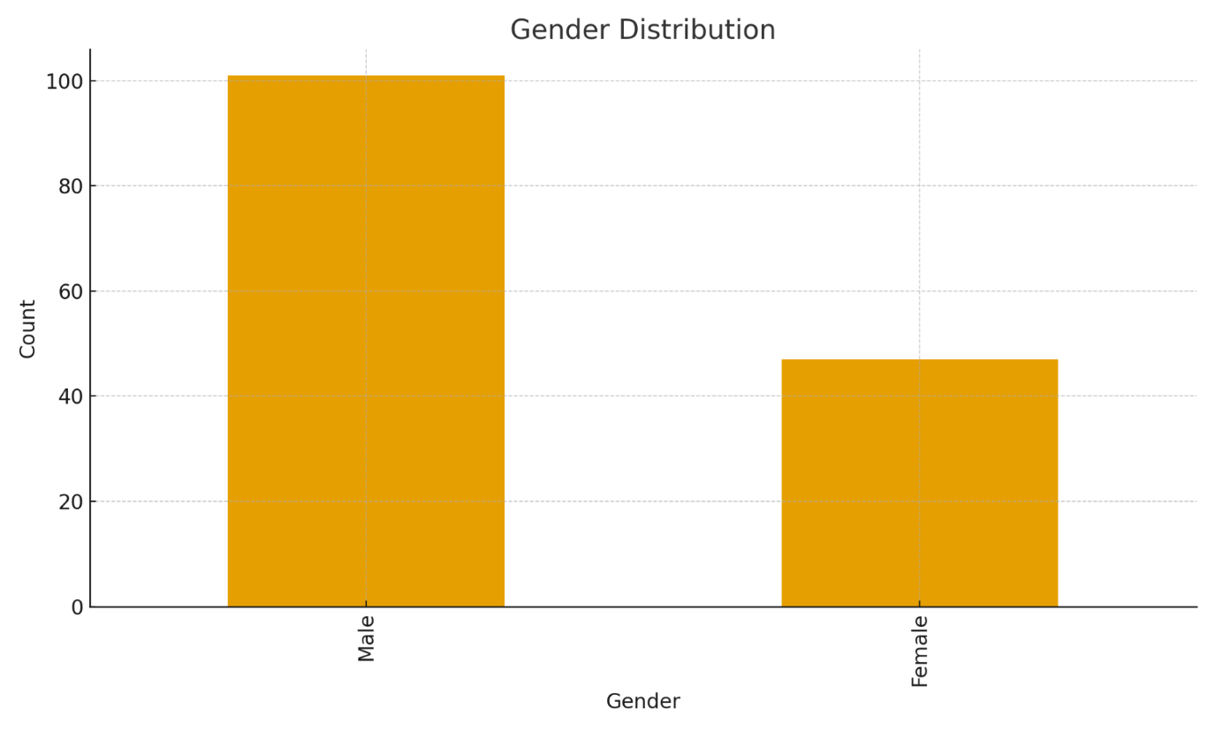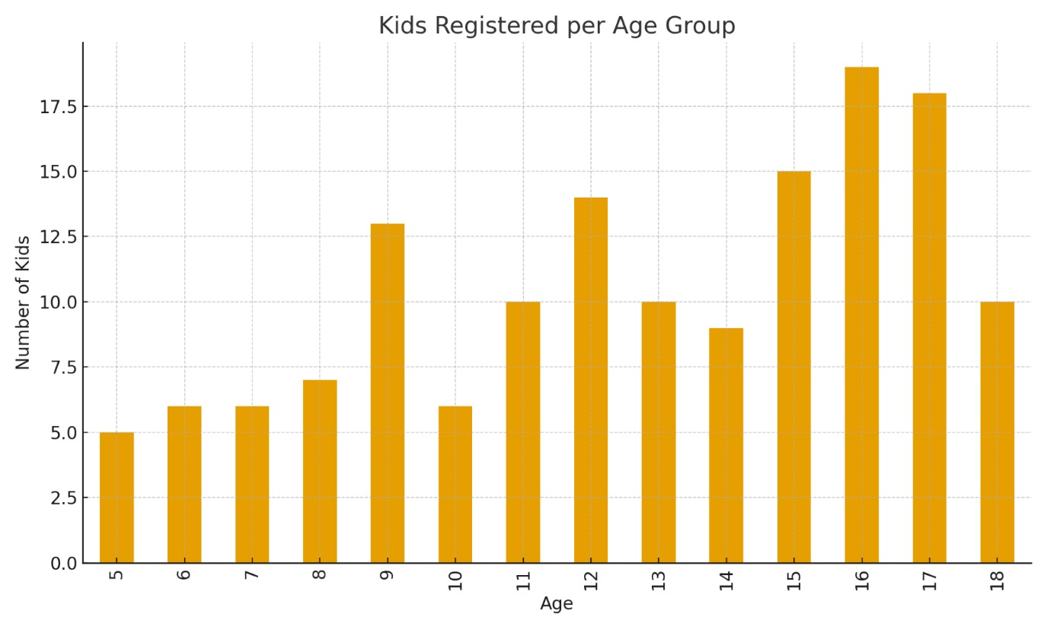

ARJU 2025 Awards:
Under 6's
Certificate of Commitment | Fergus Packer | Certificate
Certificate of Commitment | Mackenzie Webb | Certificate
Certificate of Commitment | Parker Webb | Certificate
Certificate of Commitment | Dean Hayes | Certificate
Certificate of Commitment | Banjo McFarlane | Certificate
Certificate of Commitment | Noah Eastlake | Certificate
Certificate of Commitment | Matilda Percival | Certificate
Certificate of Commitment | Zale Bates | Certificate
Certificate of Commitment | Milijana Preocanin | Certificate
Certificate of Commitment | Clarke Turner | Certificate
Certificate of Commitment | Matilda Peatfield | Certificate
Certificate of Commitment | Harrison Peatfield | Certificate
certificate of Commitment | Freddie Pearson | certificate

Boys | Under 8’s
Best & Fairest | Moritz Rylands | Trophy
Coaches Choice | William Neill | Trophy
Most Improved | Stirling Turner | Trophy
Most Consistent | Hunter Grace- Booth | Medal
 | Under 10's
Michael Fussell Courage Prize - u10s | Albi Brauer | Trophy
Best & Fairest - Best Forward u10s | Darcy Abra | Trophy
Best & Fairest - Best Back u10s | Max Dennison | Trophy
Most Improved u10s | Artie Rylands | Trophy
Most Consistent u10s | Morgan Percival | Trophy
 | Under 12's
Michael Fussell Courage Prize - u12s | Hugo Sisson | Trophy
Dale's Downtown Meats Spirit of Rugby Award | Levi Vusoniua | Trophy
Most Improved u12s | Digby Seiler | Trophy
Back of the Year u12s | Max Sabry | Trophy
Forward of the Year u12s | Lachlan Percival | Trophy
 | Under 16's
Most Improved u16s | Juno Sweeney | Trophy
Back of the Year u16s | Tom Graham | Trophy
Forward of the Year u16s | Riley Mathieson | Trophy
Players Player u16s | Isaac Brown and Riley Mathieson | Trophy
 | Under 18's
Most Improved u18s | Hunter Ward | Trophy
Back of the Year u18s | Tom Schaefer | Trophy
Forward of the Year u18s | Josh Bible | Trophy
Players Player u18s | Ollie Martin | Trophy

Girls | Under 14’s
Most Improved u14's GIRLS | Emma Birnie | Trophy
Back of the Year u14s GIRLS | Olive McFarlane | Trophy
Forward of the Year u14s GIRLS | Ella Bruce | Trophy
Players Player u14s GIRLS | Hayley Grieves | Trophy
 | Under 16’s
Most Improved u16s GIRLS | Hollie Higgins | Trophy
Back of the Year u16s GIRLS | Lily McFarlane | Trophy
Forward of the Year u16s GIRLS | Izzy McRae | Trophy
Players Player u16s GIRLS | Evie Matthews | Trophy
 | Under 18’s
Most Improved u18s GIRLS | Ella Jenkins | Trophy
Back of the Year u18s GIRLS | Molly Chard | Trophy
Forward of the Year u18s GIRLS | Zahlie Cabot | Trophy
Players Player u18s GIRLS | Beth Arandale | Trophy

Representative sides 2025
Central North Representatives 15’S
Age Groups | Players | Recognition
Under 10 | Ted Bartlett- Taylor
Under 11 | Mason Grace- Booth, Jimmy Neil, Hugo Sisson
Under 12 Boys | Lachlan Percival, Flynn Mc Farlene, Levi Vusoniua
Under 12 Girls | Isabella Scanlon
Under 15 | Issac Bown, Jack Reynell
Under 16 Girls | Georgia Scanlon
Under 18 Boys | Kai Sell- Michell
Under 18 Girls | Eliza Thompson, Matilda Thompson

New England 7’s
Age Groups | Players | Recognition
Under 13 Boys | Hunter Crane, Lachlan Percival
Under 13 Girls | Piper McLaren, Lucy Kelly
Under 15 Boys | Isaac Brown, Tom Graham, Bobby Chard, Archie Cooper, Juno Sweeney, Charlie Rice, Jack Reynell
Under 15 Girls | Izzy McRae, Evie Matthews
Under 17 Boys | Gabriel Harris, Oliver Martin,
Under 17 Girls | Eliza Thompson, Matilda Thompson

